# SQL Assignment - 4

**Q1. Create table emp which has the following attributes (employee table) (@empno, ename, job, sal, deptno) Where empno is primary key, ename is unique, job in (Prof, AP, and Lect), sal is not NULL, and deptno default is 10. Insert appropriate records, check error messages in case of violation and list all the constraint names for given table.**

**Ans1. create table emp(empno int primary key,ename char(255) unique,job char(255) check(job ='Prof' or job ='AP' or job = 'Lect'),sal int NOT NULL,deptno int default 10);**



**describe emp;**

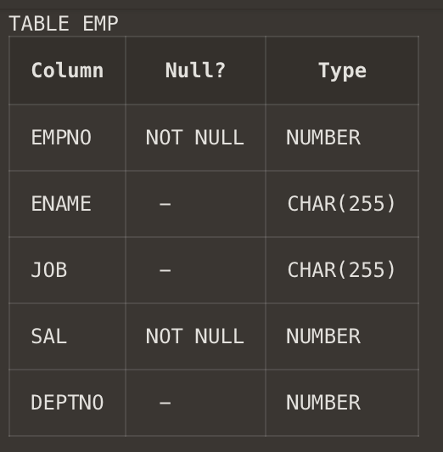

**List of constraints in thr table emp :-**

**1.2.1. primary key**

**1.2.2. unique**

**1.2.3. NOT NULL**

**1.2.4. check**

**1.2.5. default**

**inserting value and corresponding errors screenshot**

**initially the records that we entered:**

1. **insert into emp values(1,'Manan','Prof',2500000,1);**
2. **insert into emp values(2,'Samiya','AP',1500000,2);**
3. **insert into emp values(3,'Urvi','Prof',2000000,default);**
4. **insert into emp values(4,'Manav','Lect',1000000,4);**
5. **insert into emp values(5,'Pretty','Lect',1200000,9);**

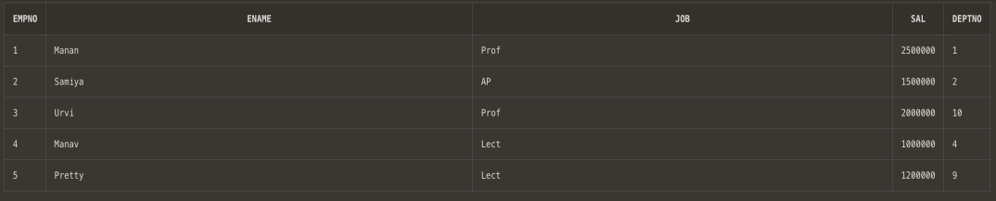

**note- here we observed use of default constraint.**

**insert into emp values(6,'Pretty','Lect',1200000,8);**



**note- here we noticed use of unique constraint**

**insert into emp values(7,'Shashank','TUT',1200000,8);**



**note- here we noticed use of check constraint**

**insert into emp values(null,'Usha','Lect',1200000,8);**



**insert into emp values(5,'Prem','Lect',1200000,8);**



**note- here in 8.1 and 8.2 we noticed Primary Key constraint.**

**insert into emp values(8,'Usha','Lect',null,8);**



**note- here NOT NULL constraint is noticed.**

**Q2. Create table book:**

**Rno number—PK**

**DOI-date**

**DOR-date**

**DOR>DOI**

**Insert appropriate records, check error messages in case of**

**violation and list all the constraint names for given table.**

**Ans2. create table book (Roll_Number int primary key, DOI date, DOR date, check(DOR>DOI) );**



**describe book;**

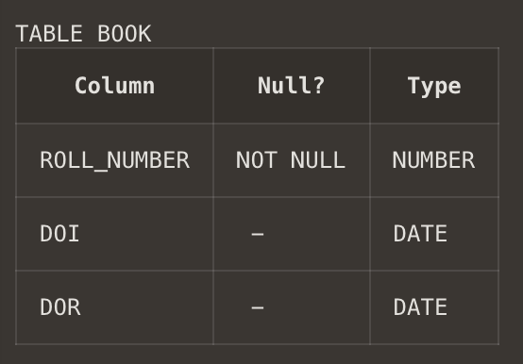

**insert into book values(1,'12/Jan/2023','12/Feb/2023');**

**insert into book values(2,'12/Jan/2023','12/Feb/2023');**

**insert into book values(3,'10/FEB/2023','13/March/2023');**

**insert into book values(4,'21/March/2023','27/April/2023');**

**insert into book values(5,'28/APRIL/2023','12/May/2023');**

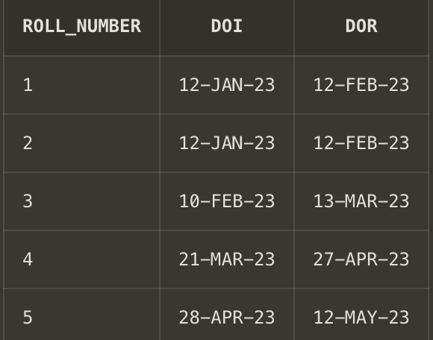

**insert into book values(5,'28/oct/2023','12/nov/2023');**

**insert into book values(null,'28/APRIL/2023','12/May/2023');**

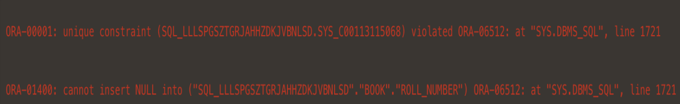

**note- primary key constraint observed here.**

**insert into book values(8,'28/JUN/2023','12/May/2023');**



**note- check constraint observed here.**

**Q3. Create table st**

**Rno-Number**

**Class-Char**

**Marks-Number**

**Primary key(rno,class)**

**Marks>0**

**Insert appropriate records, check error messages in case of**

**violation and list all the constraint names for given table.**

**Ans3. create table st(Rno int ,class varchar(255),marks int,constraint PK_Student primary key(Rno,Class));**



**describe st;**

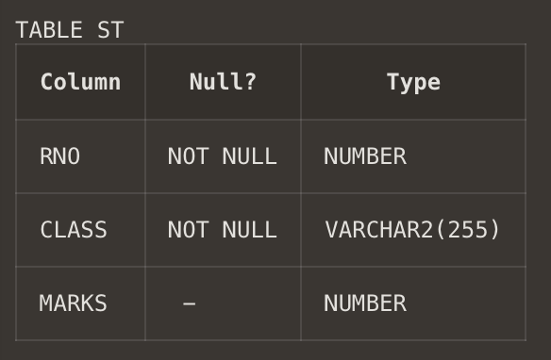

**note- here there is only one primary key that is PK_student .However, the VALUE of the primary key is made up of TWO COLUMNS (RNO +Class ).**

**insert into st values(1,'2CO8',89);**

**insert into st values(2,'2EC8',85);**

**insert into st values(3,'2NC8',91);**

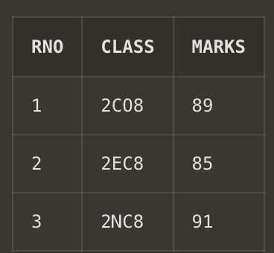

**insert into st values(4,'2CO8',90);**

**insert into st values(4,'2ME8',87);**

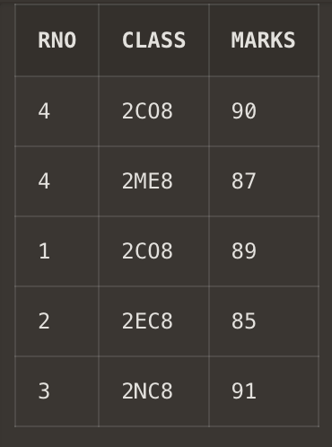

**note-here we noticed that class or Rno individually are not primary key.**

**insert into st values (2,'2EC8',90);**

**insert into st values(null,null,89);**

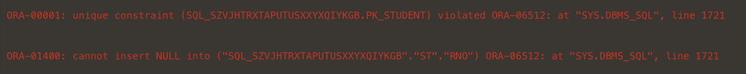

**note- here when we put the value null or repeated the value in both the column(rno and class) then only it gave error corresponding to primary key**

**Q4. Create table S which has the following attributes (Salesperson table)**

**(sno, sname, city) -> Where sno is primary key.**

**Ans4 . create table S(sno int primary key,sname char(28),city char(30));**



**insert into S values(1,'manan','delhi');**

**insert into S values(2,'urvi','mansa');**

**insert into S values(3,'manav','dehradun');**

**insert into S values(4,'shorya','najibabad');**

**insert into S values(5,'mavendra','lucknow');**

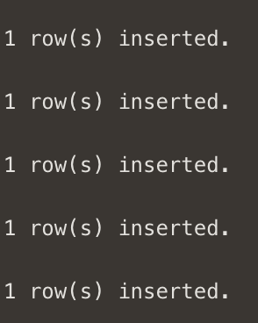

**describe S;**

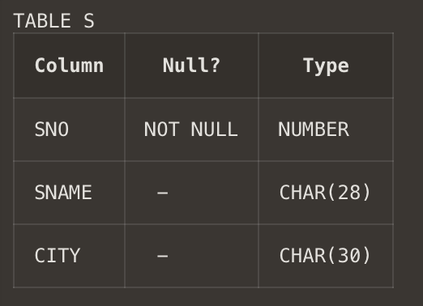

**select * from S;**



**Q5. Create table P which has the following attributes (Part table)**

**(pno, pname, color) ->Where pno is primary key**

**Ans5. create table P(pno int primary key,pname char(28),color char(30));**



**insert into P values(1,'abc','red');**

**insert into P values(2,'def','orange');**

**insert into P values(3,'ghi','green');**

**insert into P values(4,'jkl','white');**

**insert into P values(5,'mno','yellow');**

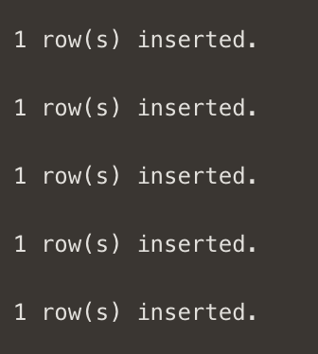

**describe P;**

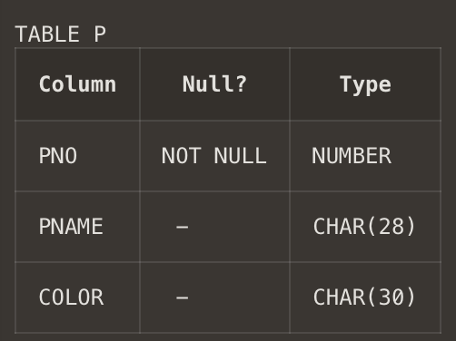

**select * from P;**

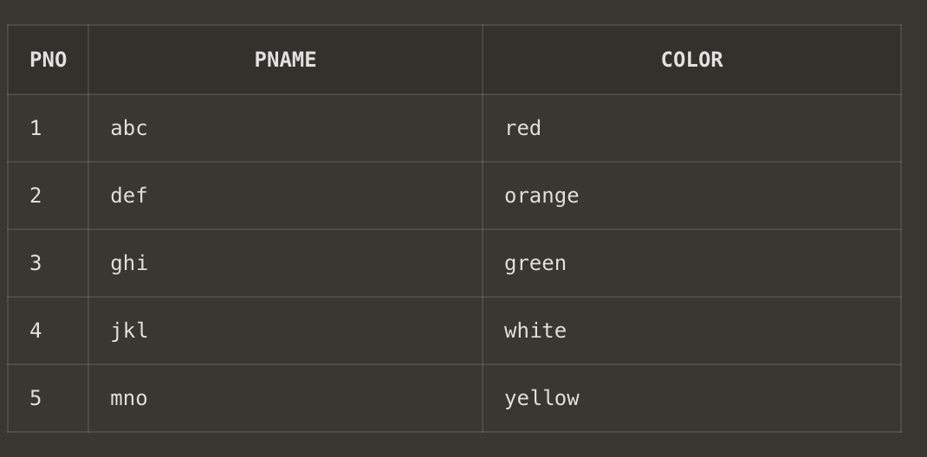

**Q6. Create table SP which has the following attributes**

**(sno, pno qty) Where combination of (sno, pno) is primary key, also sno and**

**pno are foreign keys**

**Ans6. create table SP(**

**sno int ,**

**pno int ,**

**qty int ,**

**constraint FK_per1 foreign key (sno) references S(sno),**

**constraint FK_per2 foreign key (pno) references P(pno),**

**constraint PK_per primary key(sno,pno)**

**);**



**describe SP;**

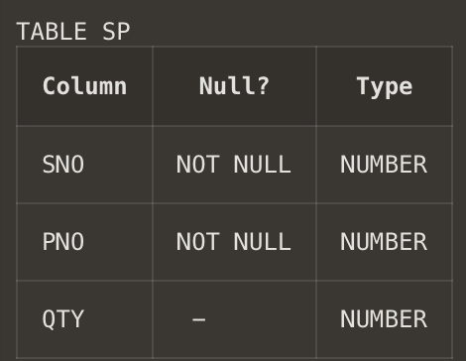

**note- here there is only one primary key that is PK_per .However, the VALUE of the primary key is made up of TWO COLUMNS (sno + pno ).**

**insert into sp values(1,1,10);**

**insert into sp values(2,2,10);**

**insert into sp values(2,3,10);**

**insert into sp values(3,4,10);**

**insert into sp values(4,4,10);**



**select * from sp;**

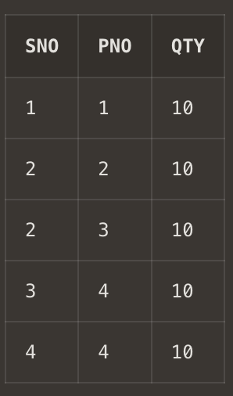

**insert into sp values(6,1,20);**

**insert into sp values(5,8,30);**



**note- This error occured because columns having constraint foreign key act as child column and no value cannot be intered into it except the ones in the parent column.**

**insert into sp values(2,3,80);**



**note- both columns(sno+pno) are primary key in combonation**

**Q7. Create table dept which has the following attributes (department table)**

**(deptno, dname)**

**Where deptno is primary key, dname in (Acc, comp, elect)**

**Ans7. create table dept(deptno int primary key,dname char(28),check(dname ='ACC'or dname ='comp'or dname='elect'));**



**describe dept;**

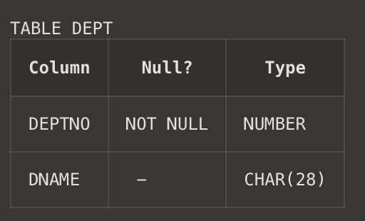

**insert into dept values(1,'ACC');**

**insert into dept values(2,'comp');**

**insert into dept values(3,'elect');**

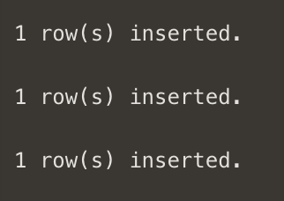

**select * from dept;**

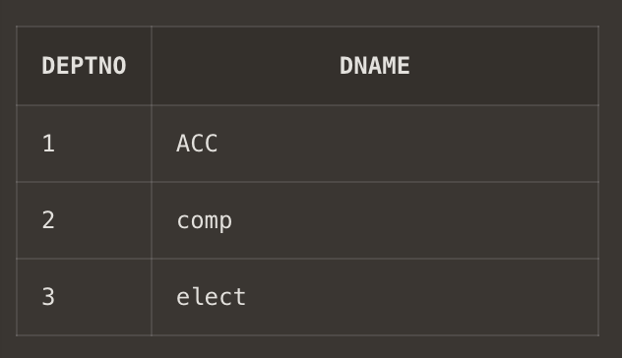

**Q8. Create table emp which has the following attributes (employee table)**

**(@empno, ename, job, sal, deptno)**

**Where empno is primary key, ename is unique, job in (Prof, AP, and Lect), sal is not NULL, and deptno is foreign key**

**Ans8. create table emp(empno int primary key,ename char(255) unique,job char(50) , sal int not null,deptno int , constraint FK_emp foreign key (deptno) references dept(deptno),check(job='Prof' or job='AP' or job='Lect'));**



**describe emp;**

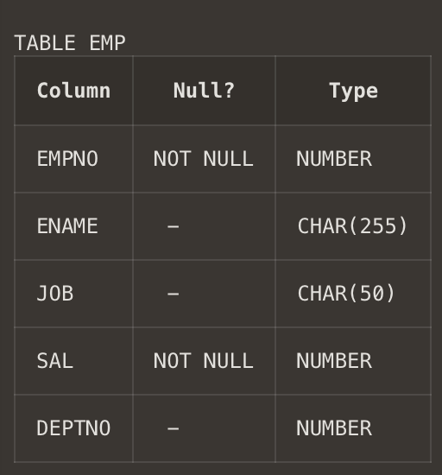

**insert into emp values(1,'abc','Prof',100000,1);**

**insert into emp values(2,'def','AP',50000,2);**

**insert into emp values(3,'ghi','Prof',100000,3);**

**insert into emp values(4,'jkl','AP',50000,3);**

**insert into emp values(5,'mno','Lect',40000,2);**

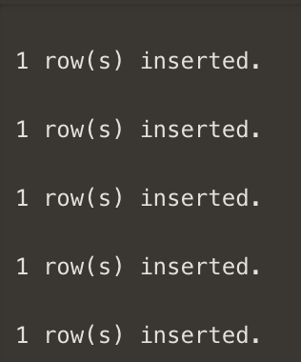

**select * from emp;**

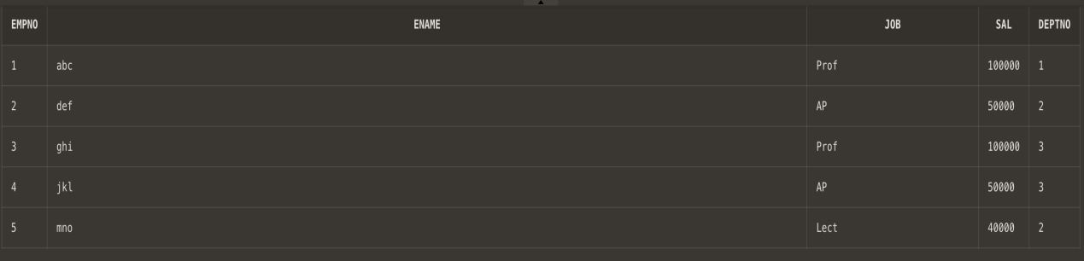

**insert into emp values(6,'pqr','Lect',40000,5);**



**note- foreign key column cannot have value different from parent column**

**insert into emp values(7,'stu','TUT',30000,3);**



**note- check constraint property not matched**